**Gateway to Islamic Knowledge**

Submitted By

**Sumaira (2020-UOBSAC-189)**

Supervised By

**Mrs. Rehana Haider**

Co Supervised By

**Mr. Irfan Kazim**

**Department of Computer Science**

**Govt. Girls Degree College Skardu**

**University of Baltistan Skardu**

July 2024



**CERTIFICATE**

This is certified that I have read and tested the work contained in the report as verification of the standard required for partial fulfillment of the degree of Bachelor in Computer Science (BSCS) period (Fall 2020-2024). I judge that the thesis is up to the standard to warrant its acceptance to the Girls Degree College, Skardu for the degree of Bachelor of Science in Computer Science.

1. External Examiner: ______________________________________________________
2. Internal Examiner: _______________________________________________________
3. Supervisor: _____________________________________________________________
4. Co Supervisor: __________________________________________________________

**Acknowledgment**

Earliest, I want to express gratitude my parents and household for their love, care, support, and martyrs. I am also ungrateful to my supervisor Mrs. Rehana Haider and co supervisor Mr. Irfan Kazim for permanently heightening me, displaying importance in my work, and benevolent me excessive path. I am also thankful to Mrs. Rehana Haider, the head of the department her support, recommendations, and help for solving problems during my research.

**Declaration**

I am acquiescing this project, titled "Gateway to Islamic Knowledge," as part of the necessities for my Bachelor of Science in Computer Science (BSCS) degree from the University of Baltistan Skardu. I completed this project with the guidance of my supervisor.

**Supervisor:**

Signature: ______________________________________

**Co Supervisor:**

Signature: ______________________________________

**Project Member:**

Signature: ______________________________________

**Sumaira 2020-UOBSAC-189**

Date: __________________________________________

**DEDICTION**

I would like to pledge this work to my remarkable parents and teachers. They have always been there for me, financially and with a lot of love. Whenever I felt discouraged they figured out in me and aided transform my faintness into powers. I will always be thankful for their encouragement and assistance, particularly in encouraging me to pursue higher education with confidence.

***Abstract***

Gateway to Islamic Knowledge is an online admission management system designed to streamline the operations of Madrassah Shahhamdan, providing a comprehensive solution for enrollment, course management, and stakeholder engagement. The system has three different panels Admin panel, Teacher panel and Student panel, offering specialized features for each user type to enhance efficiency and user experience. Students can easily enroll in the madrassah, select their courses, and access relevant information about their academic journey. Teachers can easily see enrolled students in their specific course. The admin panel offers full accessibility, enabling administrators to oversee and manage all aspects of the system, ensuring smooth operations and data integrity. This multi-panel system not only streamlines enrollment and course management but also fosters collaboration among all stakeholders (student, teacher, admin). By integrating intuitive features and robust management tools, Gateway to Islamic Knowledge empowers Madrassah Shahhamdan to build a stronger online presence, attract more students, and create a more dynamic and efficient educational environment. This online platform positions the madrassah for growth and success in the modern education.

**Table of Contents**

Chapter 1 xi

1.1 Introduction 12

1.2 Purpose of the Project: 12

1.3 Business Scope: 13

1.4. List of Deliverables: 14

1.5 Tools and Technologies Required 14

1.6 Project Timeline 15

Chapter 2 16

2.1 Requirement Specification 17

2.2 Software Requirements Analysis 17

Chapter 3 19

3.1 Description of the System Design Architecture: 19

3.2 Software Architecture 20

3.3 System Use Case Modeling 21

3.4 Data Flow Diagram 22

3.5 Entity Relationship Diagram 23

3.6 Applying to the Online Admission System 24

3.7 Sequence Diagram 25

3.8 User Interface Design 25

Chapter 4 37

4.1 Data Collection and Management 38

4.2 Data Migration: 38

4.3 Integration with Server: 38

4.4 Performance Optimization: 38

4.5 Testing and Debugging: 39

**4.5.1 Key Benefits for Educational Institutions** 39

**4.5.2 Student-Centric Features** 39

Chapter 5 40

5.1 Testing 41

5.2 Deployment 41

Chapter 6 42

6.1. Conclusion: 42

6.2. Future Work: 43

Chapter 7 45

7.1 References 46

Chapter 8 47

**List of Figures**

Figure 1: Business Modal Sample for Gateway to Islamic Knowledge 13

Figure 2: Use Case Diagram for Gateway to Islamic Knowledge 22

Figure 3:Data Flow Diagram for Gateway to Islamic Knowledge 23

Figure 4:Entity Relationship Diagram 23

Figure 5:Sequence Diagram for Gateway to Islamic Knowledge 25

Figure 6:Homepage Screen 26

Figure 7:Homepage Course Screen 27

Figure 8:Sign-Up screen 27

Figure 9:Log-In Screen 28

Figure 10:Contact us page 28

Figure 11: Successful Submitted Form Screen 29

Figure 12: :Admission Page 30

Figure 13:Enrollment Page 31

Figure 14:Campus Page 31

Figure 15:Faculty Page 32

Figure 16:About-Us Portal 32

Figure 17:Admin Dashboard 33

Figure 18:Teacher Dashboard 33

Figure 19:Student Dashboard 34

Figure 20:Register User 34

Figure 21:Enrolled Student 35

Figure 22:Shortlisted Student 35

Figure 23:Available Course 36

Figure 24:Cancelled Admission 36

Figure 26:User Interface view Code 48

Figure 27:Admission Form View Code 48

Figure 28:Image Validation Code 49

Figure 29:Login Form Validation View Code 49

Figure 30:Email Conformation Code 50

Figure 31:Course Update view code 50

Figure 32:AI Report 51

Figure 33:Plagiarism Report 52

Figure 34:Plagiarism Report 53

**List of Table**

Table 1: Software and Hardware Requirements 14

Table 2: Project Timeline 15

# **Chapter 1**

**Introduction**

# **1.1 Introduction**

In today’s digital world, educational institutions face increasing challenges in managing administrative tasks, academic records, and stakeholder engagement effectively. Old paper-based admission system is inefficient, time-taking, money-wasting and chance to errors, leading to delays and mismanagement. To address these challenges, Gateway to Islamic Knowledge, a comprehensive School Management System, has been developed to modernize and streamline the operations of Madrassah Shahhamdan. This system is designed to cater to the diverse needs of all stakeholders, including students, teachers and administrators, through these specialized panels. The Student Panel simplifies the enrollment process, allowing students to select courses and access their academic information seamlessly. The Teacher Panel provides tools to access enrolled students in their course. At the core of the system, the Admin Panel offers full control, allowing administrators to oversee operations, manage users, and maintain system integrity. By integrating these features, Gateway to Islamic Knowledge not only enhances administrative efficiency but also fosters collaboration among stakeholders, ensuring a smooth and dynamic educational experience. This innovative solution reflects the madrassah’s commitment to embracing technology for better resource management and improved academic outcomes, positioning it as a leader in the modern educational landscape.

# **1.2 Purpose of the Project:**

The primary purpose of the **Gateway to Islamic Knowledge** is to modernize and streamline the management processes at Madrassah Shahhamdan by transitioning from traditional paper-based methods to a comprehensive digital system. This system is designed to address the inefficiencies and challenges faced by the Madrassah Shah Hamdan, such as excessive paperwork, time delays, and limited accessibility for stakeholders. project aims to provide distinct functionalities for students, teachers and administrators through specialized panels that cater to their unique requirements. It seeks to simplify student enrollment, facilitate efficient course management for teachers and empower administrators with robust tools for overseeing all operations. Ultimately, the **Gateway to Islamic Knowledge** is focused on fostering an efficient, transparent, and collaborative environment that improves the quality of education and administrative processes. By leveraging technology, the system not only streamlines operations but also strengthens the madrassah’s digital presence, making it more competitive in the modern educational system.

# **1.3 Business Scope:**

The **Gateway to Islamic Knowledge** provides a comprehensive, scalable solution designed to meet the administrative and academic needs of educational institutions, such as Madrassah Shahhamdan. The system’s scope covers key operational areas, ensuring a seamless transition from traditional methods to a fully integrated digital platform.

One of the core features of the system is **student enrollment and course management,** which simplifies the enrollment process and allows students to select courses that align with their academic goals. This functionality ensures accurate record-keeping and reduces the possibility of errors associated with manual paper-based processes. The **teacher operations** feature enables teachers to see student enroll in their course, while streamlining their workload and improving educational outcomes. This strengthens the relationship between the institution and student, ensuring active participation in the education. Administrators benefit from **full control** of the system, with access to tools that allow them to manage users, admissions process, student shortlisted or canceled admission delete old data, courses, content, and maintain system integrity, ensuring efficient and transparent operations. Additionally, the system is designed to be both **scalable and customizable**, making it adaptable to the needs of different educational institutions, regardless of size. By addressing these various aspects, **Gateway to Islamic Knowledge** enhances operational efficiency, fosters collaboration among all stakeholders, and supports the growth and modernization of Madrassah Shahhamdan, as well as other similar institutions. 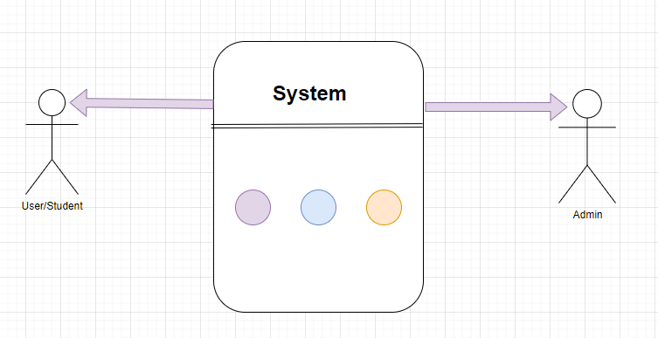

Figure 1: Business Modal Sample for Gateway to Islamic Knowledge

# **1.4. List of Deliverables:**

The **Gateway to Islamic Knowledge** will deliver a comprehensive set of components to ensure the effective implementation of an online admission management system. The first deliverable is the

**Student Panel,** a user-friendly interface that allows students to easily enroll in offered courses, see their admission status shortlisted or cancelled their enrollment. The second key deliverable is the **Teacher Panel,** which provides teachers to see enrolled students in their assign course. For administrators, the project will deliver the **Admin Panel,** which offers full control over user management, course management, admission management, teacher assign course management, and system maintenance. A key feature of the system is the Online **Enrollment System,** a streamlined digital process that allows students to register for courses, eliminating the inefficiencies of paper-based methods. The project will also include **Data Security and Backup** mechanisms, ensuring that all sensitive information is securely stored and regularly backed up. These deliverables will collectively ensure the successful implementation of the **Gateway to Islamic Knowledge**, enhancing both administrative efficiency and educational outcomes at Madrassah Shahhamdan.

# **1.5 Tools and Technologies Required**

Table 1: Software and Hardware Requirements

|  |  |
| --- | --- |
| **NAME OF COMPONENT** | **SPECIFICATION** |
| 1. Front-end tool & technologies | HTML5, CSS3, JavaScript, J query |
| 2. Back-end tool & technologies | Php |
| 3. Database | MYSQL |
| 4. Code editor | Vs. code |
| 5. Operating system | Windows |
| 6. Browser | Google chrome, Opera and Mozilla etc. |

# **1.6 Project Timeline**

Table 2: Project Timeline

|  |  |  |  |  |  |
| --- | --- | --- | --- | --- | --- |
| Month | 1 month | 2 months | 3 months | 2 months | 1 month |
| 01 | Planning |  |  |  |  |
| 02 |  | Designing |  |  |  |
| 03 |  |  | Coding |  |  |
| 04 |  |  |  | Testing |  |
| 05 |  |  |  |  | Delivery |

# **Chapter 2**

**Requirement Specification and Analysis**

# **2.1 Requirement Specification**

The **Requirement Specification** defines the functional, non-functional, and system requirements essential for the successful development and implementation of the **Gateway to Islamic Knowledge**. These specifications are designed to ensure that the system meets the needs of all stakeholders, including students, teachers and administrators, while adhering to high standards of performance, usability, and security.

The **functional requirements** of the system include the development of individual panels for students, teachers and administrators. The **Student Panel** will allow students to enroll in courses. The **Teacher Panel** will enable teachers see student enroll in their assign course. The **Admin Panel** will provide full control for managing users, creating and updating courses. The **Enrollment System** will streamline student enrollment, allowing for course selection and registration, with real-time updates on available courses. In terms of **non-functional requirements**, the system must be user-friendly, with an intuitive interface that is accessible across multiple devices, including desktops and mobiles. It should be highly performant, ensuring minimal loading times and scalability to accommodate increasing numbers of users and data. Security is a top priority, with encrypted data storage, secure authentication, and authorization mechanisms to protect user information. The system must be reliable, with high availability and backup systems in place to prevent data loss. It will also need to comply with relevant data protection and privacy regulations, ensuring that users' personal and academic data are protected.

The **system requirements** include the use of modern web development technologies, such as HTML5, CSS3, JavaScript and JQuery for the front-end and a robust database management system like MySQL to handle user and academic data. The platform will be hosted on a cloud infrastructure to ensure scalability and reliability, with access available through standard web browsers on both desktop and mobile devices. A stable internet connection will be required for access, but the system should be optimized to perform well in low-bandwidth environments.

These specifications lay the groundwork for the development of the **Gateway to Islamic Knowledge**, ensuring that it delivers a reliable, efficient, and secure solution for Madrassah Shah Hamdan administrative and academic needs.

# **2.2 Software Requirements Analysis**

The Software Requirements Analysis for the Gateway to Islamic Knowledge system focuses on the essential software components and technologies necessary to build an effective, user-friendly, and scalable system. This analysis covers the front-end development, back-end functionality, database management, and security requirements to ensure the system meets the needs of all users and performs efficiently.

For the front-end development, the system utilizes HTML5, CSS3, JQuery and JavaScript. These technologies are used to create a responsive and visually appealing user interface for students, teachers and administrators. HTML defines the structure of the web pages, CSS is used for styling the interface, ensuring it is clean and user-friendly, while JavaScript provides interactivity and dynamic content loading. These technologies together ensure that the system is accessible across various devices, including desktops, tablets, and smartphones.

On the back-end, server-side technologies are used in conjunction with the front-end technologies to handle user authentication, data processing, and server communication. technology like PHP are considered to interact with the front-end and manage the back-end functionality, ensuring smooth data handling and security.

For database management, MySQL is employed as the relational database management system (RDBMS) for storing and managing the data. MySQL is an open-source database that offers robust performance, scalability, and security features, making it an ideal choice for handling student, teacher and course data. It stores data such as user credentials, course information, student enrollment records. The relational model of MySQL ensures that data is organized efficiently, enabling quick retrieval and updates. In terms of system security, key measures are implemented to ensure that sensitive data is protected. Additionally, password hashing techniques such as bcrypt, hashed password are employed to store user credentials securely, protecting them from unauthorized access. The system also includes user authentication mechanisms to ensure only authorized users can access specific functionalities. The Software Requirements Analysis for the Gateway to Islamic Knowledge outlines a combination of front-end technologies (HTML, CSS, JavaScript) and a robust back-end technologies(Php)with MySQL for data storage and management. The system prioritizes security, performance, and scalability to provide an optimal experience for all users, including students, teachers and administrators.

# **Chapter 3**

**System Design**

# **3.1 Description of the System Design Architecture:**

The architecture of the Gateway to Islamic Knowledge is designed with a client-server model to provide a modular, scalable, and secure solution. The client side is responsible for presenting data and interacting with the users, while the server side handles the core processing, including user authentication, data processing, and communication with the database. The system includes four main panels tailored to different user roles: students, teachers and administrators. Each panel is designed to meet the specific needs of its user group, allowing students to access their admission status, teachers to see enrolled students in their assign course, and administrators to oversee the all system. The system relies on MySQL as its relational database management system (RDBMS) to store all data. This includes tables for users, courses, enrollments, role, admin, student, teacher. The relational database ensures that data is organized and easily accessible for querying and reporting purposes. Security is a primary concern in the design, and the system have several layers of protection. These measures ensure that sensitive data is kept safe, and users have access only to the features relevant to their roles. The server then communicates with the database to retrieve or update information as needed. This includes adding new user roles or integrating additional course management features. The user interface is designed with ease of use in mind, ensuring that all users, regardless of technical expertise, can navigate the system easily. Responsive design techniques ensure that the system works well on a variety of devices, from desktops to mobile phones. In conclusion, the system architecture for the Gateway to Islamic Knowledge project combines robust backend infrastructure, user-friendly interfaces, and strong security practices to deliver an effective and adaptable solution for Madrassah Shah Hamdan. This design ensures the system will meet current educational needs while being flexible enough for future enhancements.

# **3.2 Software Architecture**

The software architecture of the Gateway to Islamic Knowledge follows a multi-tier structure that is designed to provide scalability, maintainability, and robust performance. It is organized into three primary layers: The Presentation Layer, the Business Logic Layer, and the Data Access Layer. The Presentation Layer is responsible for providing the user interface (UI) that interacts with various users, including students, teachers and administrators. It is built using front-end technologies such as HTML5, CSS3, JavaScript, and jQuery, ensuring that the system is responsive and offers a seamless experience across devices like desktops, tablets, and mobile phones.

The Business Logic Layer, or server-side, contains the core processing logic of the system. It is developed using server-side languages like PHP and handles key functionalities such as user authentication, course enrollment, teacher management, student management. It also ensures that the data sent from the presentation layer is correctly processed, and interactions with the data access layer are efficient and secure. Role-based access control is applied here to restrict access to functionalities based on user roles, such as admin, teacher, student. This layer also handles academics updates.

The Data Access Layer is responsible for managing all persistent data and is typically powered by a relational database management system, such as MySQL. This layer stores critical information like user profiles, course details. The database is designed using a relational model to ensure data integrity and minimize redundancy, with SQL queries used to interact with the stored data. Security measures are crucial here, with sensitive data encrypted to protect user privacy. In conclusion, the software architecture of the Gateway to Islamic Knowledge is designed to offer a structured, secure, and scalable solution, ensuring that each layer functions independently yet efficiently to provide a seamless and secure user experience. Through its use of modern technologies and layered design, the system remains flexible, secure, and easy to maintain, adapting to the evolving needs of the madrassah Shah Hamdan.

# **3.3 System Use Case Modeling**

To clearly illustrate how people, interact with the online admissions system, we created a visual map. This map breaks down the process into user roles and their actions within the system.

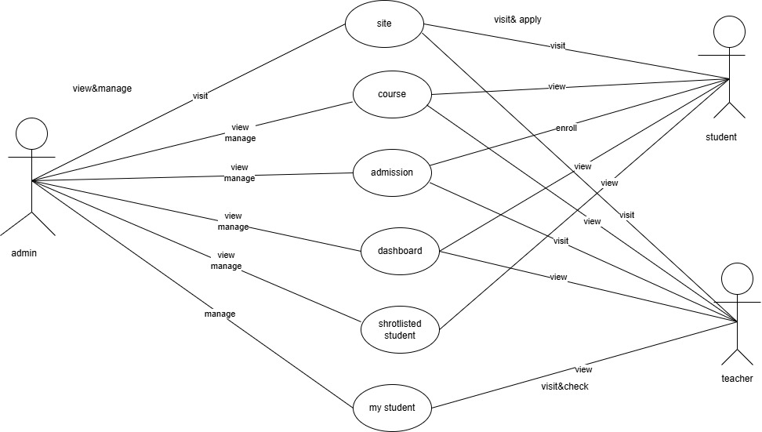

Figure 2: Use Case Diagram for Gateway to Islamic Knowledge

# **3.4 Data Flow Diagram**

Imagine a blueprint for your Online admission system. That is essentially what a level 0 DFD, or context diagram. It provides a high-level overview, picturing the system as a single process. This process interacts with external entities, such as applicants or administrators, who provide data or receive outputs.

For a more detailed look, level 1 DFDs come in. Reason of them as increasing in on the perspective figure. They break down the single process into its major sub-processes, offering a clearer picture of how different parts of the system work together. In naiver positions, a level 1 DFD is like a burst out sight of the circumstance figure, tightfitting the internal mechanisms of the core process.

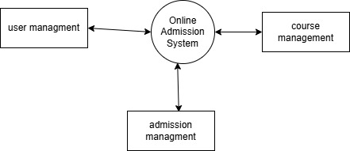

Figure 3:Data Flow Diagram for Gateway to Islamic Knowledge

# **3.5 Entity Relationship Diagram**

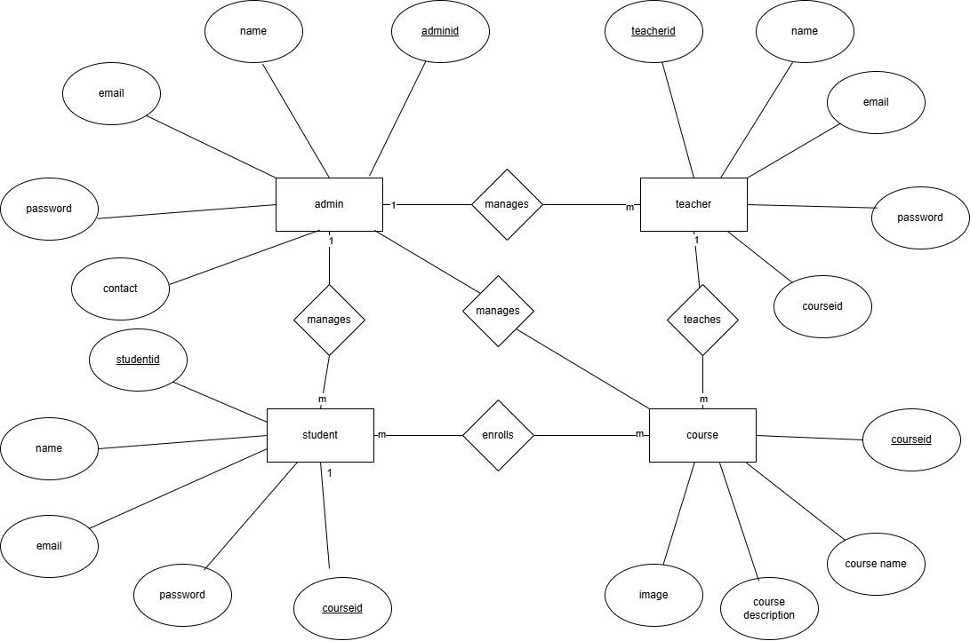

Figure 4:Entity Relationship Diagram

# **3.6 Applying to the Online Admission System**

The **Online Admission System** for the Gateway to Islamic Knowledge streamlines the enrollment process, allowing prospective students to apply for admission to Madrassah Shah Hamdan through a user-friendly, digital platform. This system simplifies the traditional paper-based application process, offering a more efficient, transparent, and accessible way for students to enroll.

To apply to the Online Admission System, students need to follow a structured procedure, which is designed to ensure accuracy and clarity. The process typically begins with the creation of an account on the platform. New applicants will be required to provide essential personal information such as their name, contact details, previous educational background, and any additional documents or certificates that may be necessary for admission. Once the account is created, applicants can proceed to fill out the admission form, where they can select their preferred courses, specify their academic interests, and upload passport-sized photographs.

The system allows students to view available programs and courses, along with descriptions, schedules, and requirements, making it easier for them to make informed decisions. Additionally, students can choose from various specializations or subjects offered by the madrassah Shah Hamdan based on their educational goals.

Once the form is completed, the student submits the application for review. Administrators review the submitted applications and may request further clarification or documentation if needed.

Applicants can also track the status of their admission application in real time through their student panel. The system will update applicants on whether their application has been approved, rejected. If the admission is successful, the system sends out a final confirmation email, along with instructions for completing the registration process and preparing for classes.

The **Online Admission System** helps reduce administrative workload, minimizes errors, and accelerates the processing time for applications. By enabling a seamless online application process, the system ensures greater accessibility for students, regardless of geographical location, while also enhancing the overall efficiency and organization of the madrassah’s enrollment procedures.

# **3.7 Sequence Diagram**

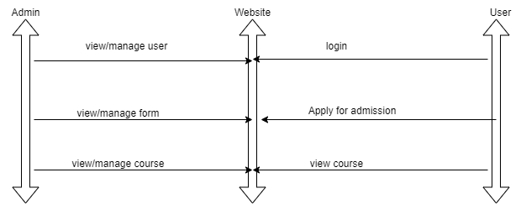

Figure 5:Sequence Diagram for Gateway to Islamic Knowledge

# **3.8 User Interface Design**

The user interface design for the Gateway to Islamic Knowledge is a fundamental component of the system's overall usability. It is crafted to ensure that users, including students, teachers and administrators, can interact with the system efficiently and effectively. The design prioritizes simplicity, clarity, and ease of navigation, providing a seamless experience across all user groups.

For students, the UI offers a clean and user-friendly layout. The student panel is designed with essential sections such as course management, and all accessible through a clear navigation bar. The dashboard displays the student's enrollment status. The teacher panel is tailored to streamline tasks such as course based enrollment management. The admin panel offers a comprehensive interface for managing the system's overall operations. Administrators can easily manage user accounts, oversee course enrollments, and track system performance. The dashboard displays key metrics such as the number of active students and courses, ensuring that administrators can monitor the system’s health at a glance. The interface is also designed for managing academic records, providing administrators with the tools they need to oversee the system effectively.

The system employs a responsive design, ensuring that it works seamlessly on various devices, from desktops to mobile phones. The color scheme is professional and calming, featuring soft blues and whites, which contribute to a visually appealing and stress-free experience. Navigation elements are consistent and intuitive, with clearly labeled icons and buttons to guide users through the system. The font size is optimized for readability, ensuring that the system is accessible to users with different visual abilities. Error messages and system notifications are displayed in a non-intrusive way, helping users to resolve any issues quickly and efficiently.

Overall, the user interface design of the Gateway to Islamic Knowledge focuses on providing an intuitive, accessible, and efficient experience for all stakeholders. By emphasizing ease of use and responsive design, the system ensures that users can navigate through their tasks with minimal effort and maximum efficiency.

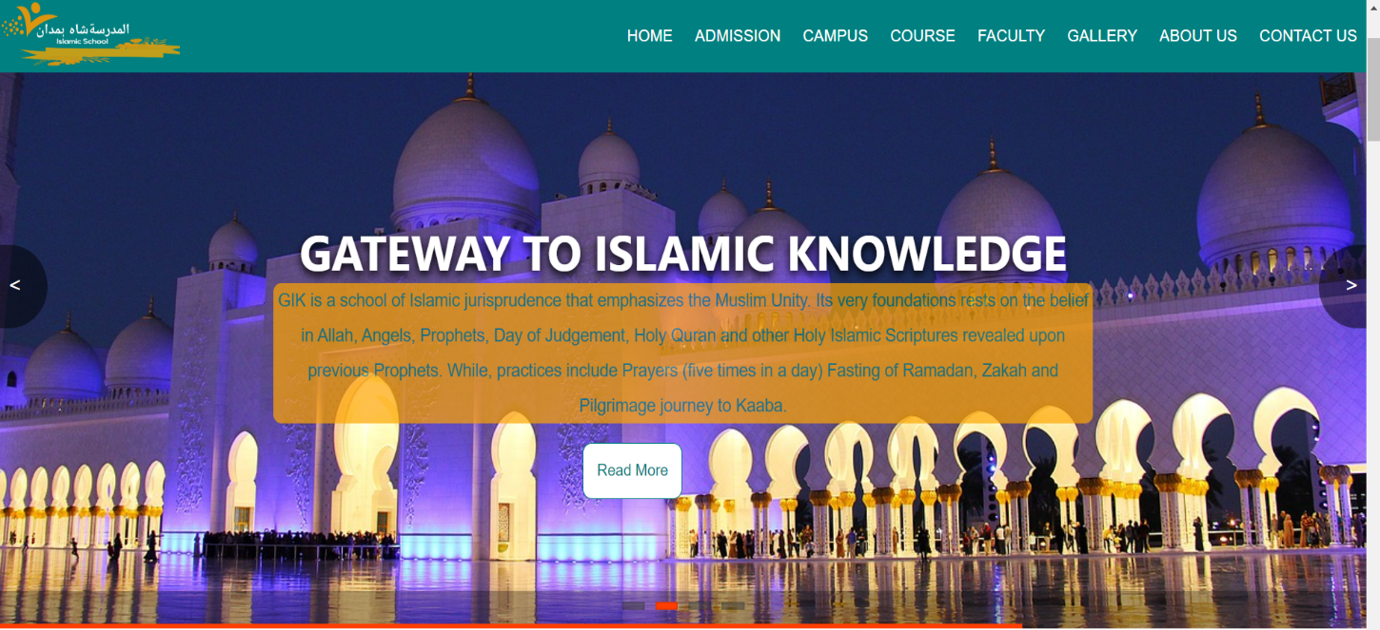

Figure 6:Homepage Screen

The user sees the first screen as soon as the website is launched that contains the following features:

The page contains menu bar items that enables the users to access different sections of the website easily and get more information’s about the website. After the header menu bar there is a brief message about Madrassah Shahhamdan.

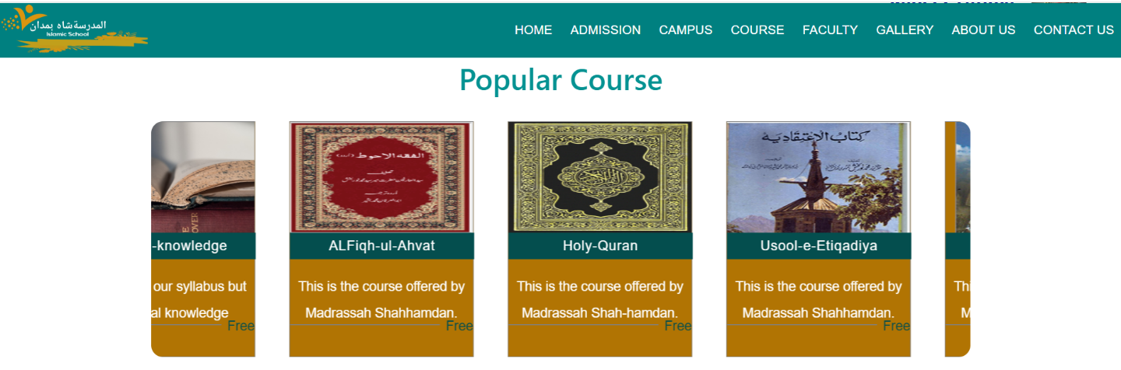

Figure 7:Homepage Course Screen

Prospective students can find information about available courses by visiting the "Course" page on the navigation bar. This page displays all the courses offered by the Madrassah for the current academic year.

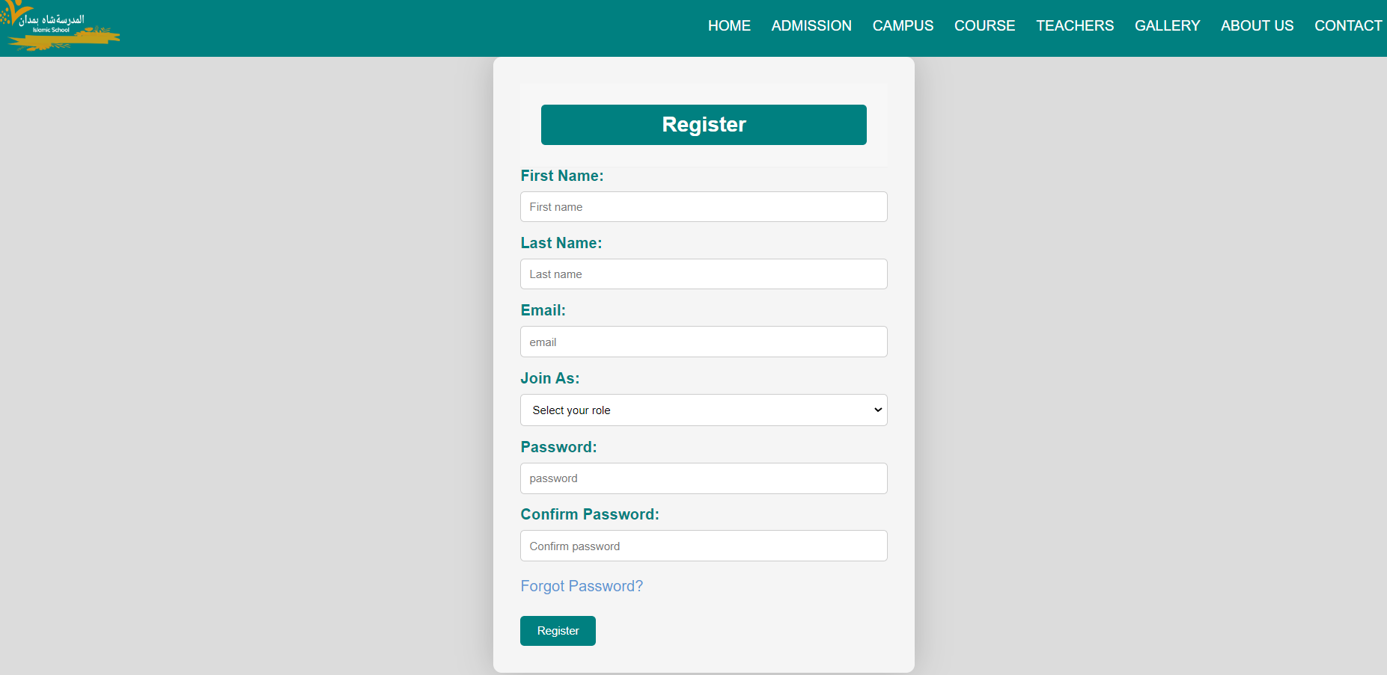

Figure 8:Sign-Up screen

From this page the user can register them by filling the details given above in the page including name, email and passwords. After completing the requirements by clicking the button (REGISER) they come to the login page.

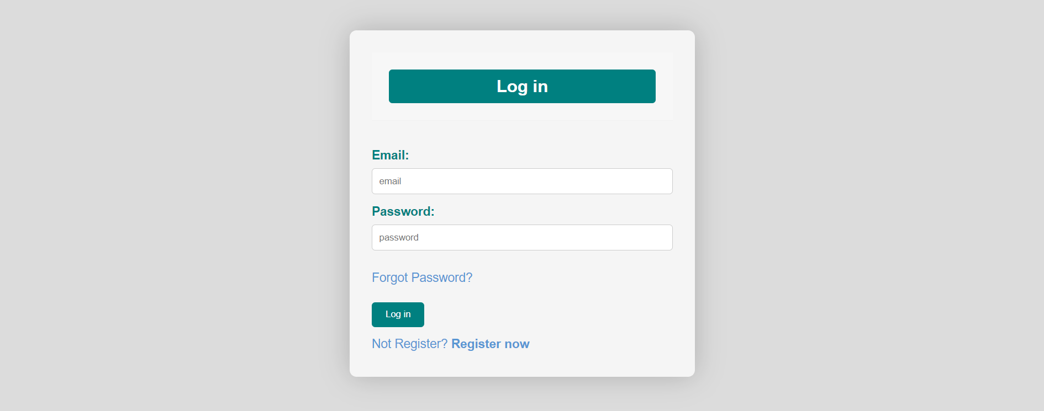

Figure 9:Log-In Screen

After completing the registration process users see the login page as shown in above figure and can logged-in by clicking on the button (Login). Just by logging in successfully, users can access the admission form.

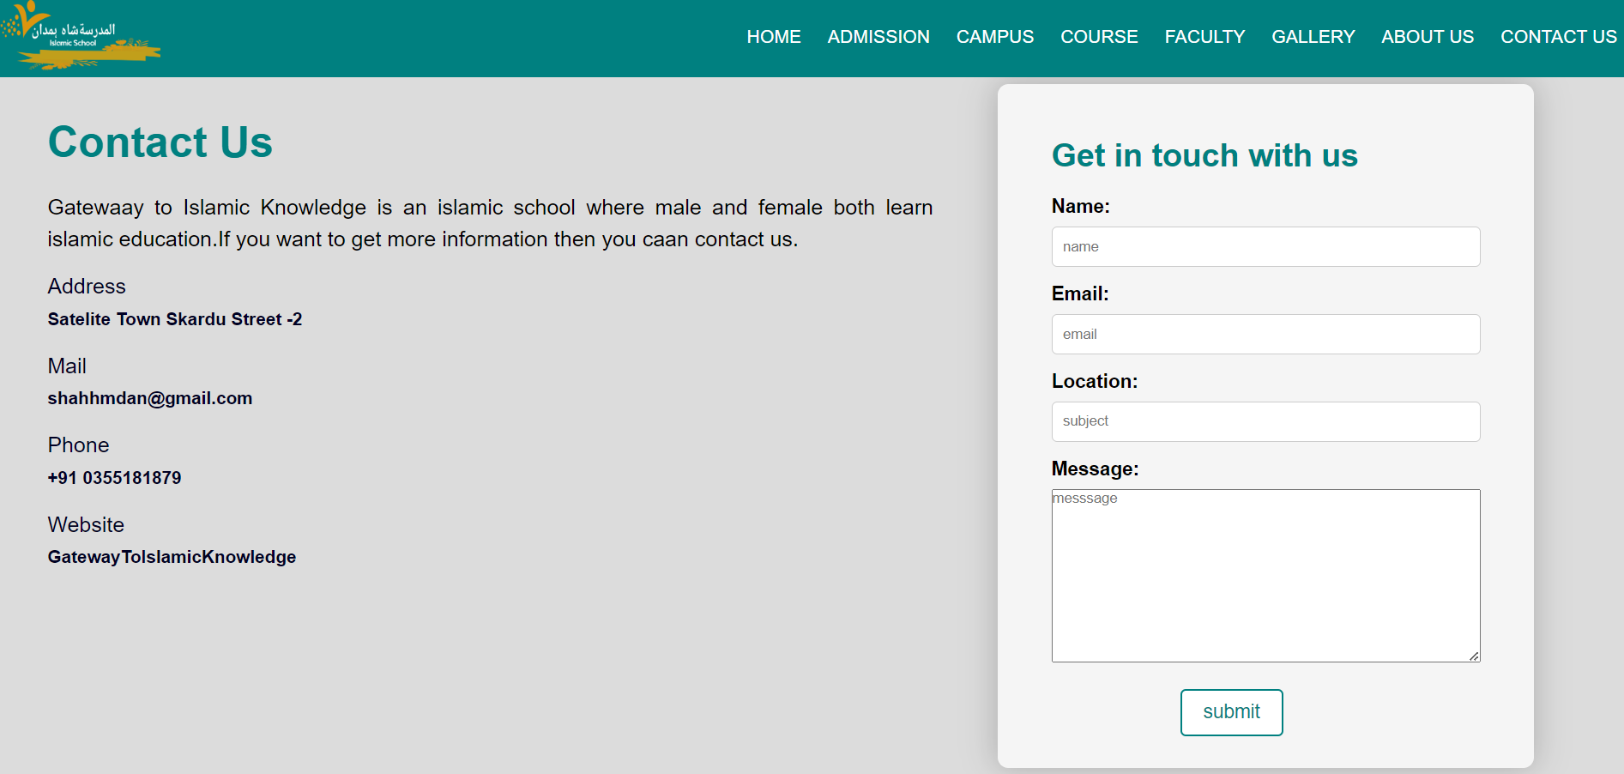

Figure 10:Contact us page

The page has a contact form where you can enter your name, email, message.

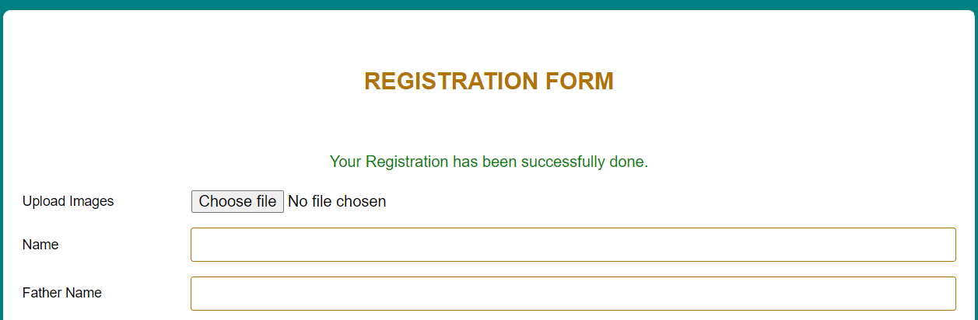

Figure 11: Successful Submitted Form Screen

This page shows the complete summary of users’ form details get the successful message on the top of the page.

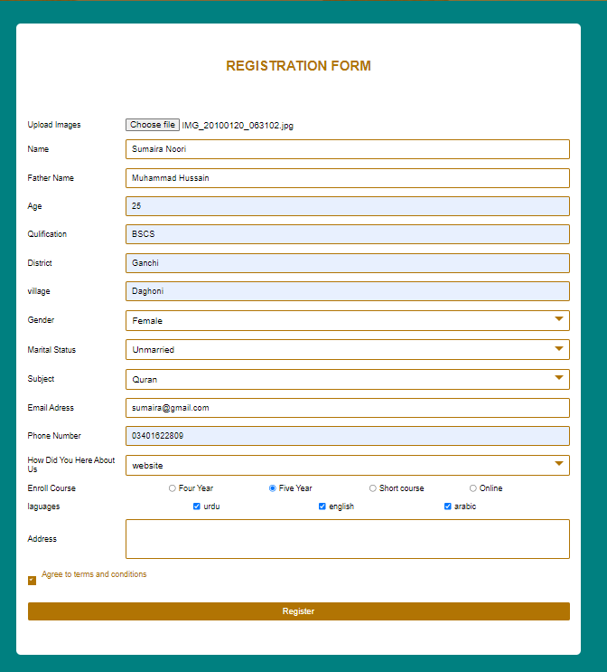

Figure 12: :Admission Page

This is the user admission form where they can fill the form by filling all the requirements and save their information’s by clicking on the button (Register) and can secure their admissions for a bright future.

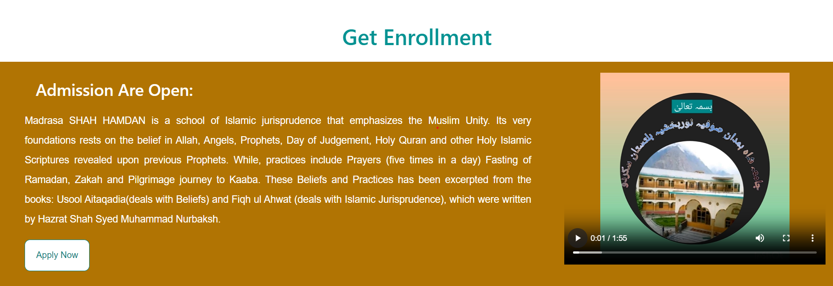

Figure 13:Enrollment Page

**This is the enrollment section where prospective students can easily apply to the Madrassah by clicking the "Apply Now" button.**

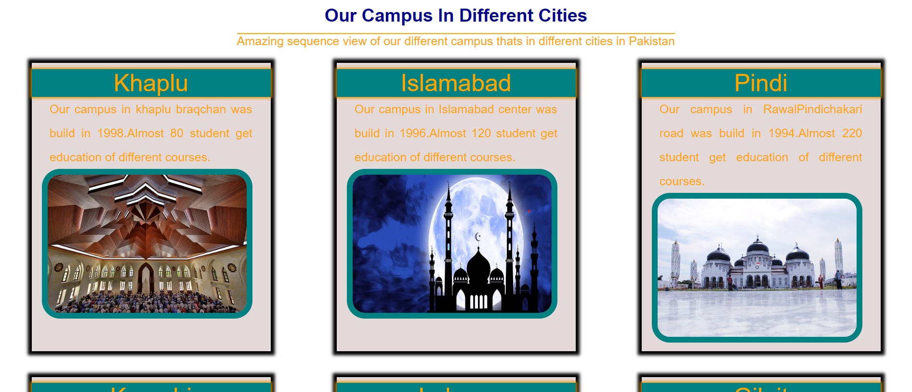

Figure 14:Campus Page

This is the campus page where all the details about the campus locate in different cities are given.

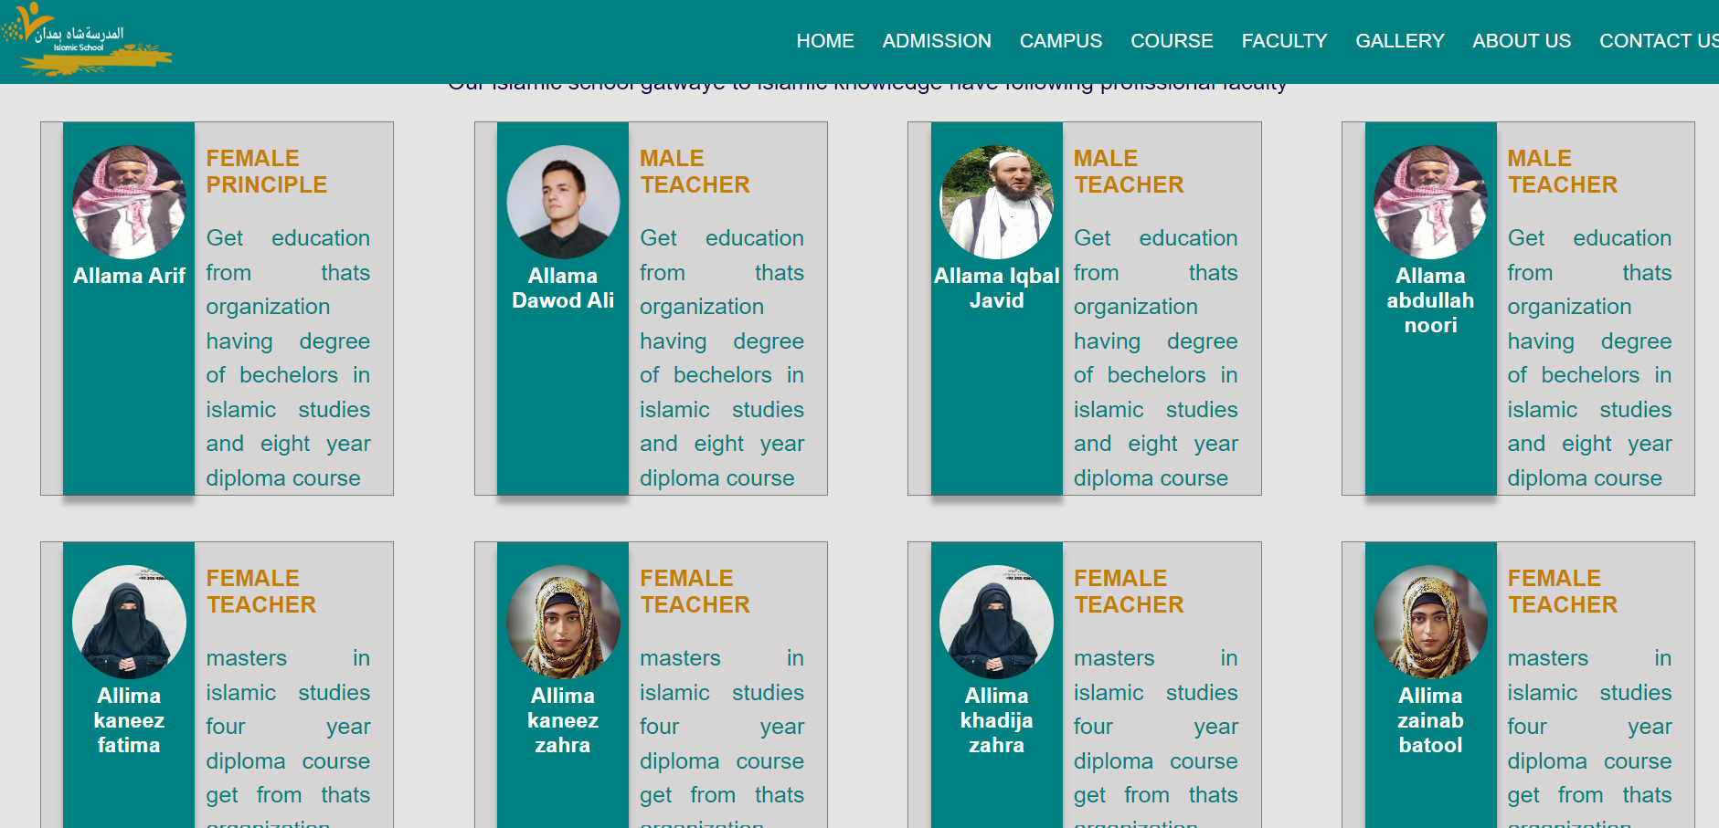

Figure 15:Faculty Page

This is the faculty page where all the details about faculty like their name image and some basic info.

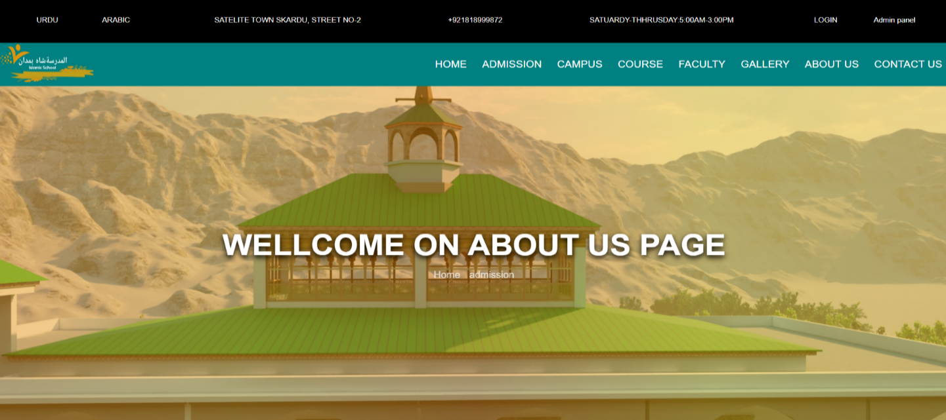

Figure 16:About-Us Portal

This is the about us landing page where all the details about the institution are given and from here there is an option to easily redirect to the home page by clicking on Home.

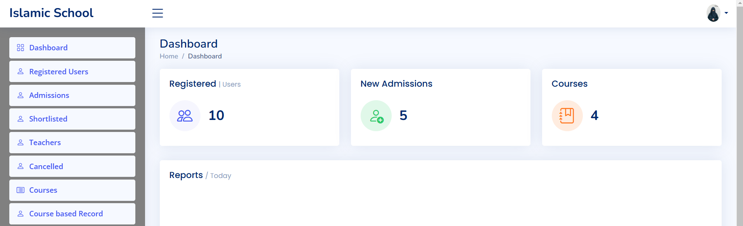

Figure 17:Admin Dashboard

This Super Admin Dashboardtracks administrator login times, displays the number of registered users, shows the number of submitted admission forms, provides insights into the number of courses offered and modernizes completed and envisages the fraction of male and female users by district.

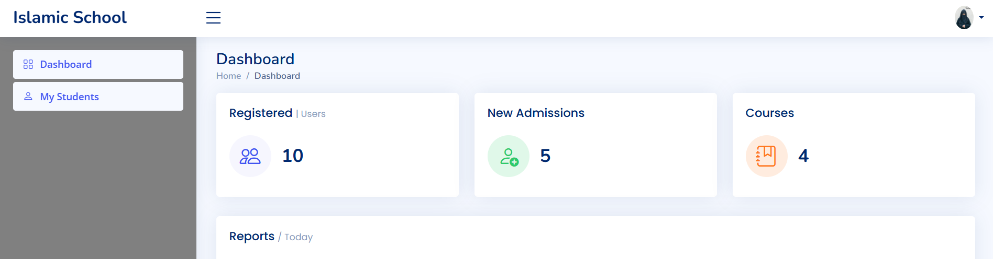

Figure 18:Teacher Dashboard

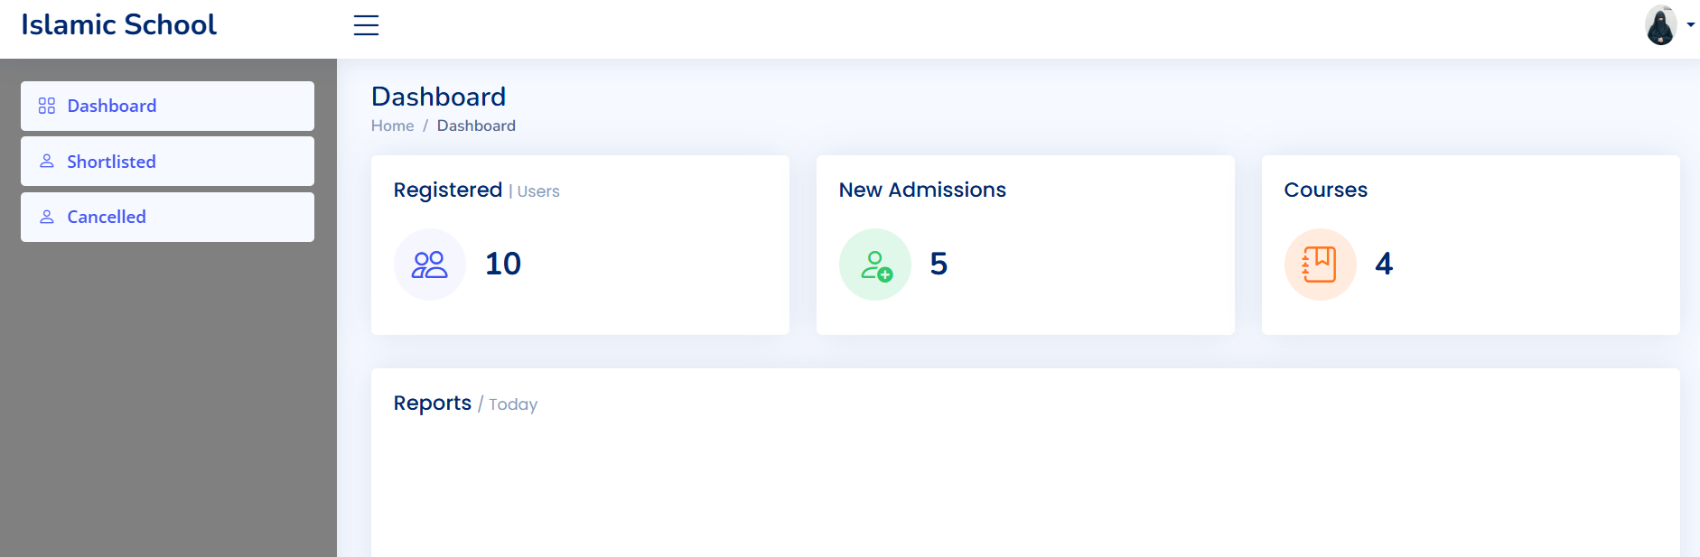

Figure 19:Student Dashboard

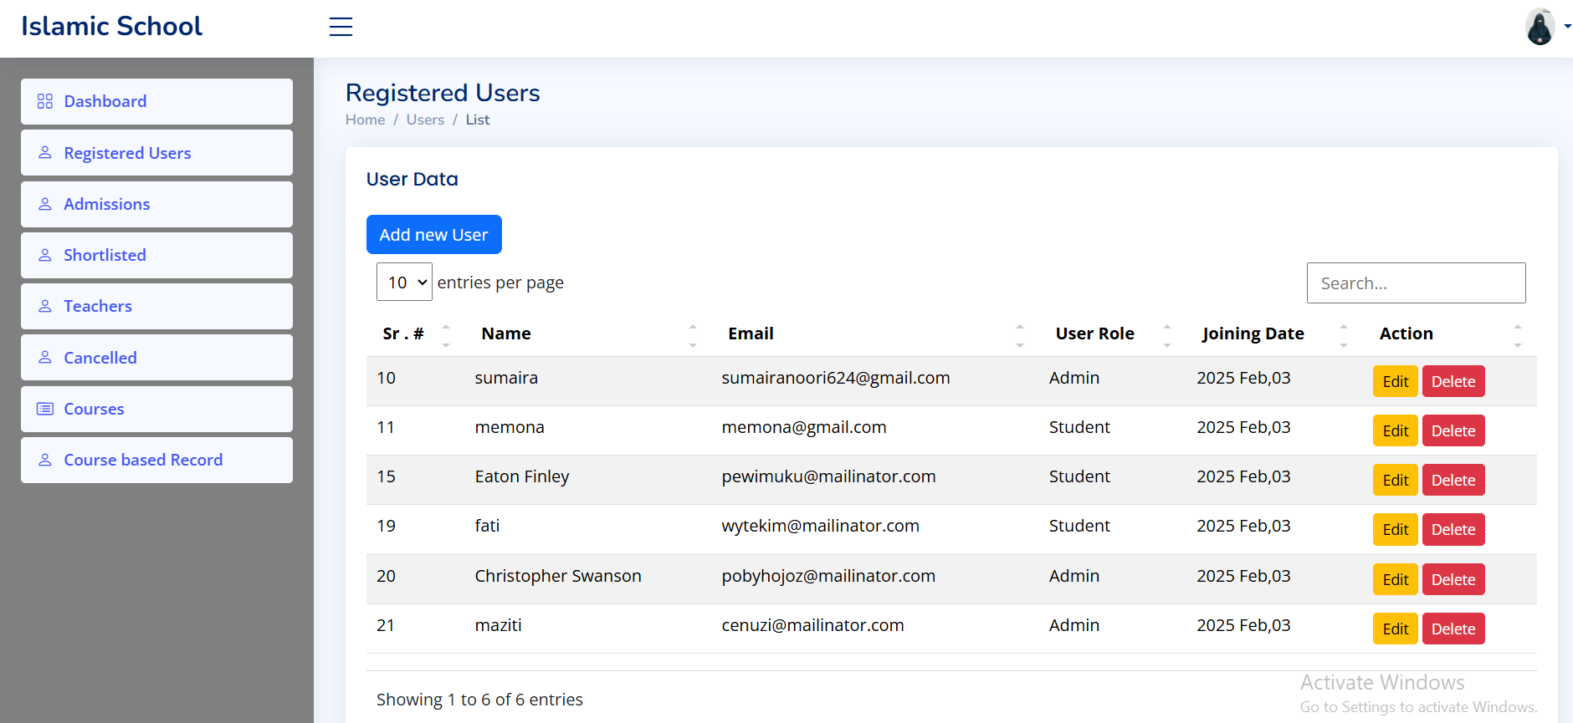

Figure 20:Register User

This Super Admin Dashboard provides a centralized view of all registered users. It empowers administrators with the ability update existing user profiles to ensure accuracy, remove inactive or unauthorized users from the system, dedicated function streamlines the creation of new user accounts, specifically designed to simplify administrator tasks.

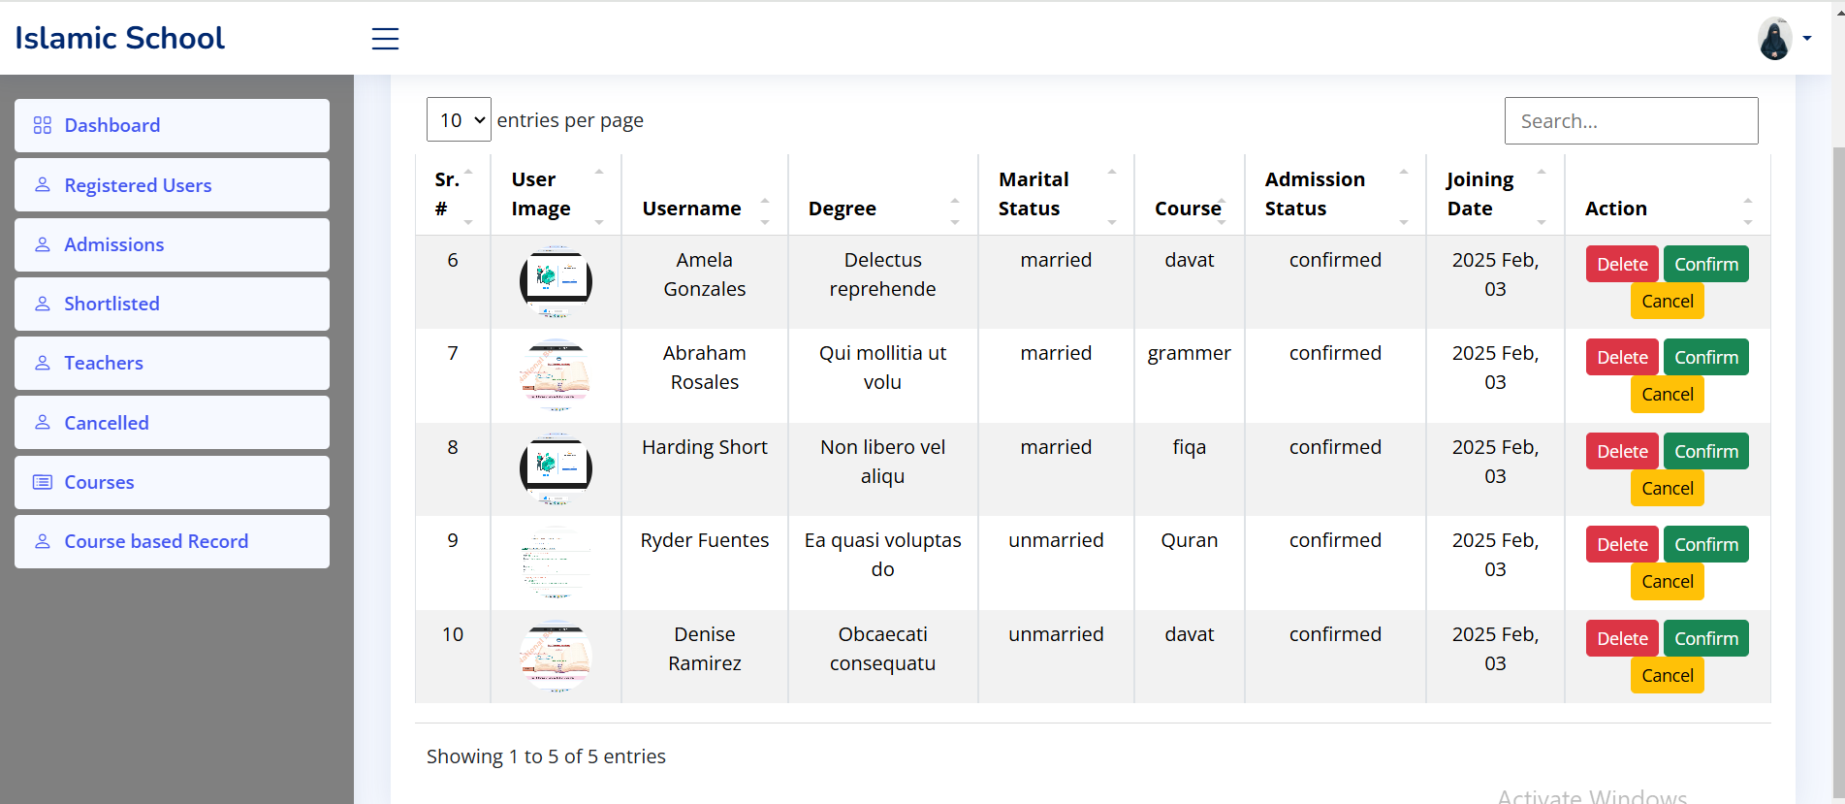

Figure 21:Enrolled Student

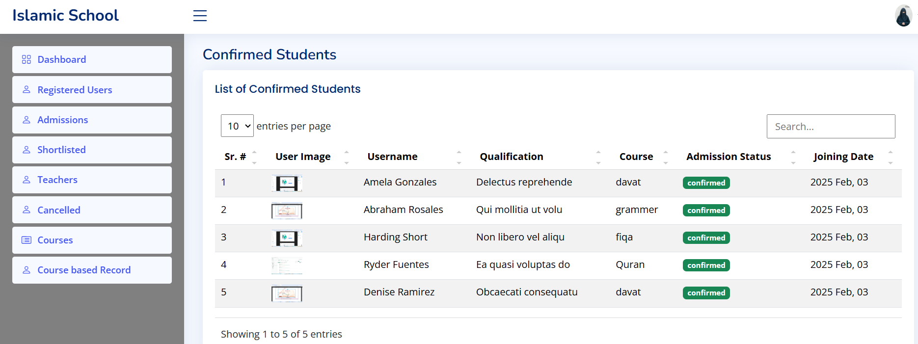

Figure 22:Shortlisted Student

This Super Admin Dashboard provides a comprehensive view of all applicants. It grants administrators the authority to: approve applications that meet the program requirements, reject applications that do not meet the program requirements or in case of duplicate entries, remove incomplete or irrelevant applications from the system.

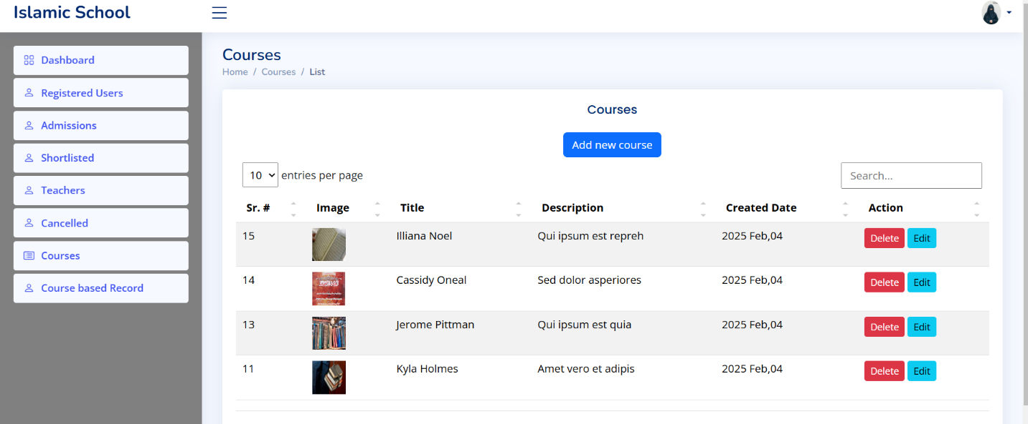

Figure 23:Available Course

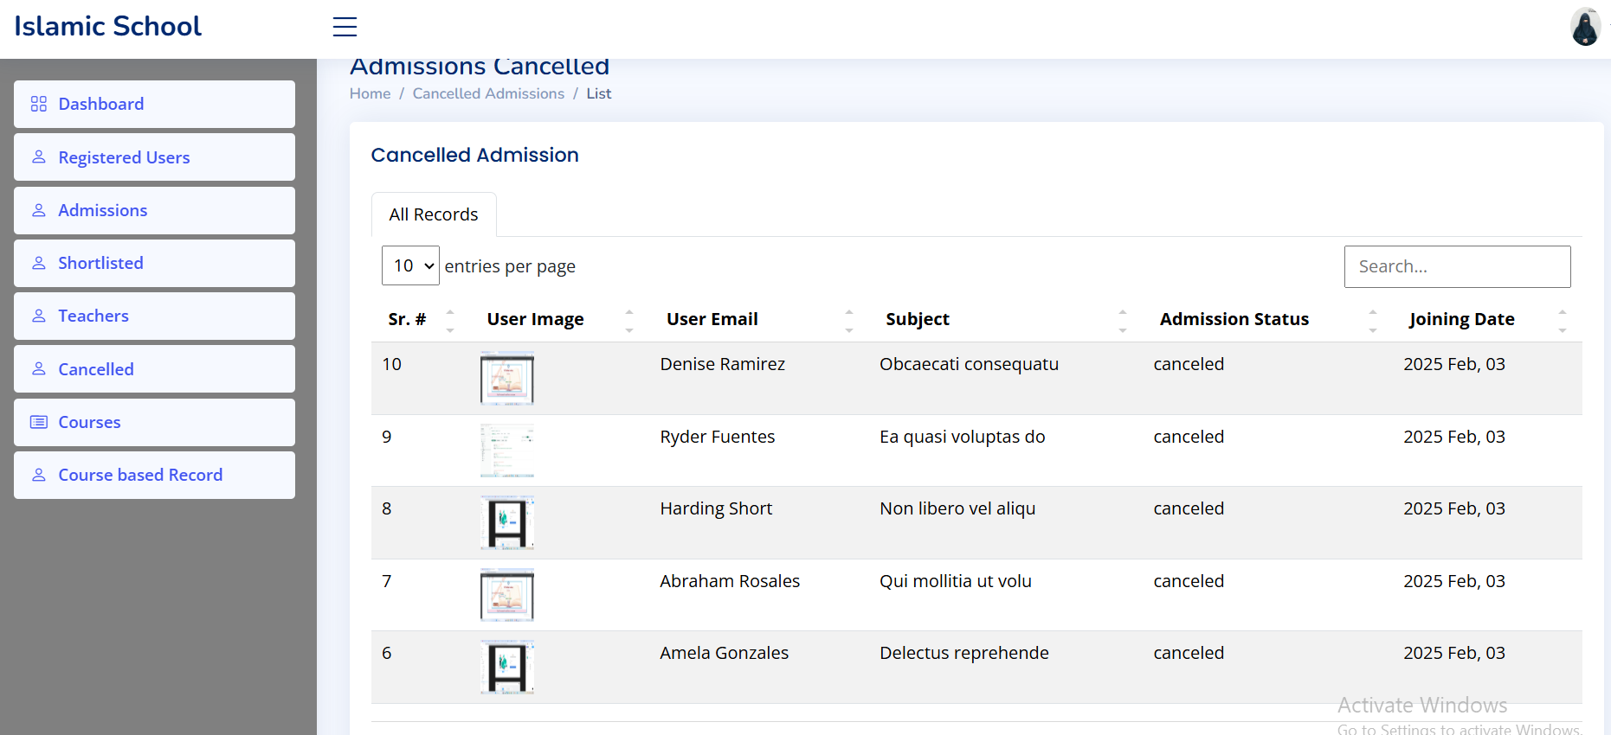

Figure 24:Cancelled Admission

# **Chapter 4**

**Implementation**

# **4.1 Data Collection and Management**

Our team actively ensures the accuracy and completeness of educational institutions' data, despite the fact that educational institutions are currently responsible for entering it into the Admission Portal. However, difficulties arise because some local stakeholders, particularly administrators, may not be well-versed in technology. When courses are managed by individuals with less technical expertise, the process can become cumbersome, despite the fact that Madrassah generally feel comfortable selling courses on independent platforms. Besides, solid web availability is basic for powerful information the board. In our case, SCO is the only internet service provider in the region. Because unanticipated interruptions like road closures on the Skardu-Jogloat route can damage fiber optic cables and disrupt our internet connectivity, this reliance introduces a potential risk.

# **4.2 Data Migration:**

Planning is essential when migrating existing admission data to the new system, which includes records, applications, and historical data about students. If not handled with the utmost care, this procedure can be complicated and result in the loss of data. Before launching the new system, we are currently carrying out extensive testing and comprehensive data integrity checks to reduce these risks. For your protection, we will also keep a safe backup of your original data.

# **4.3 Integration with Server:**

The Admission Portal is currently hosted on our development computers' local Apache servers. Moving to a cloud server is absolutely necessary given the limited financial resources at hand. Nevertheless, supplementary finance or speculation is necessary to safe as houses raincloud member of staff serving at table accommodating.

# **4.4 Performance Optimization:**

At what time production with a huge amount of manipulators at the same time, the arrangement may involvement stoppages or clatters. We are enthusiastically quiet out freight challenging to agreement horizontal maneuver in real-world environments. We are able to heighten catalogue questions and program as compulsory to warrant finest presentation cheers to the support of this analysis in uncovering system-wide concert tailbacks.

# **4.5 Testing and Debugging:**

A complete challenging scheme is required for construction a vigorous operational entrance fee organization. Numerous functionalities, such as user recordkeeping, request submission, and directorial responsibilities, will be scrupulously established in an assortment of circumstances as part of this plan. By delineation online ratification background is a dynamic web presentation projected to dismayed how educational institutions oversee verifications. The submission process can be modernized, there will be clearness, and this user-friendly display place will ultimately maintenance the enlargement of the local instruction sector.

## **4.5.1 Key Benefits for Educational Institutions**

Foundations can resourcefully update program statistics by integrated course super vision, guaranteeing that schoolchildren have admittance to the most modern details. The stand diminishes administration and expands productivity by reshuffling the submission process for both foundations and candidates. Moreover, upgraded deceivability through the stage inducements in a more wide-ranging pool of competent contenders. Furthermore, the system makes available useful data perceptions that can be used to sustenance premeditated decision-making apropos admissions stratagems and course contributions.

## **4.5.2 Student-Centric Features**

An unassuming and operative claim practice that can be accomplished at any time, from any whereabouts, is expedient to schoolchildren. The raised area provides complete statistics about curriculums, ticket price wants, and cutoff date and acts as a consolidated statistics hub. We give schoolchildren the capability to make sophisticated choices about their enlightening journey by actuality open and reachable.

# **Chapter 5**

**Testing and Deployment**

# **5.1 Testing**

An inclusive difficult timetable was put into residence in command to assurance that Madrassah Shah Hamadan’s operational admittance scheme would be executed successfully. System taxing, component testing, and pretending real-world situations with organization difficult were all parts of this development. Incorporation challenging looked at how innumerable components interact with one alternative. During getting challenging, we amended the arrangement to meet the specific necessities of interviewees and organizational staff by integrating treasured criticism from key participants. The system's functionality, trustworthiness, and ease of use were failsafe by this demanding methodology.

# **5.2 Deployment**

A scrupulous disposition process was obligatory for the operative employment of the online admittance system at Madrassah Shah Hamdan. The organization software and catalogue were indeed installed and configured after careful deliberation of the best presenting raised area. During the changeover from a paper-based system, a horizontal passage of remaining student records was passed out to agreement the truthfulness of the data. Matriculation staff and superintendents established widespread physical activity to simplify well-organized administration of the new podium, provisional on the complication of the system. Subsequently the prearrangement and investigation were operational, the organization was made obtainable to the municipal. In order to statement any probable issues and ensure worst performance, ongoing watching and preservation were carry out. This indispensable organization assured a unswerving progress to the new web-based endorsement background, eventually giving a sharp out and operational understanding for the two contenders and monitoring workforce.

# **Chapter 6**

**Conclusion and Future Work**

# **6.1. Conclusion:**

The Gateway to Islamic Knowledge has been developed as a comprehensive solution to address the administrative and academic challenges faced by Madrassah Shah Hamdan. By transitioning from traditional, paper-based methods to a fully digital platform, the system aims to streamline processes, enhance efficiency, and foster better communication among all stakeholder’s students, teachers and administrators. The system’s design focuses on ease of use, functionality, and accessibility, ensuring that each user group can effectively perform their tasks and engage with the system.

For students, the system simplifies enrollment. Teachers benefit from a well-organized interface that enables them to see student enrolled in their assign course. Administrators are equipped with powerful tools to manage user accounts, courses, and academic records, ensuring smooth and transparent operations.

The system’s user-friendly interface, responsive design, and integration of key features such as course management and dynamic educational environment. Additionally, the system’s security features, including encrypted data storage and secure authentication, ensure that sensitive information is protected, making the platform reliable and trustworthy for all users.

In conclusion, the Gateway to Islamic Knowledge has successfully fulfilled its purpose of modernizing the administrative and academic processes at Madrassah Shahhamdan. It provides a scalable, adaptable solution for educational institutions looking to improve operational efficiency, enhance stakeholder collaboration, and build a more dynamic online presence. The system not only supports the madrassah’s current needs but also positions it for growth and success in the competitive and ever-evolving landscape of modern education.

# **6.2. Future Work:**

The current online Admission System represents an important tread in reorganization the admittances progression, yet the vision extends elsewhere its current competences. To further enhance the user experience and optimize institutional processes, several key improvements are envisioned.

Secure payment assimilation, real-time application tracking, and a dedicated communication gateway will knowingly upraise the applicant practice. By providing a mobile application and advanced reporting proficiencies, the system can better cater to the evolving needs of both applicants and institutions. These enrichments will not only streamline processes but also empower decision makers with valuable data driven visions.

By investing in these future progresses, the Virtual Admittance Gateway can become an even more crucial tool for the edification zone, nurturing efficiency, clearness, and student fulfilment.

# **Chapter 7**

**References**

# **7.1 References**

[1] H. Tuhuteru and R. Siwalette, “System Design and Implementation of Online Admission System at XYZ University,” *Inspir. J. Teknol. Inf. dan Komun.*, vol. 12, no. 2, pp. 105–117, 2022.

[2] D. Kurniadi, A. Mulyani, Y. Septiana, and H. Aulawi, “Estimated software measurement base on use case for online admission system,” in *IOP Conference Series: Materials Science and Engineering*, 2018, vol. 434, no. 1, p. 12062.

[3] J. S. Balasaheb, S. B. Sitaram, W. V. Khushalrao, V. N. Ashok, and M. P. Bhausaheb, “Web Based College Admission System,” *IJEDR*, 2014.

[4] A. Auddy and S. Mukhopadhyay, “Modelling Online Admission System: A Multi-Agent Based Approach,” *Int. J. Mod. Educ. Comput. Sci.*, vol. 6, no. 5, p. 26, 2014.

[5] K. Arpitha, “A Study On Online College Admission Management System.”

[6] F.-T. Sabiha, “Online postgraduate admission system a case study,” 2019.

[7] M. Fujo, “Centralized admission system for advanced level private schools: case of Kilimanjaro region, Tanzania.” NM-AIST, 2019.

[8] R. Bhuvaneshwari, P. Prasath, G. Manikandan, and V. Ponraj, “Web Based Admission Analysis System,” 2019.

[9] J. Mincer-Daszkiewicz, “Student Admission System for Warsaw University,” in *EuNIS’2004, The 10th International Conference of European university Information Systems*, 2004.

[10] S. Sularto, W. Wahyudi, and S. Sukmawati, “The Admission of New Students Based on Online System at SMAN 2 Singkawang,” *J. Educ. Teach. Learn.*, vol. 3, no. 2, pp. 336–341, 2018.

# **Chapter 8**

**Appendix**

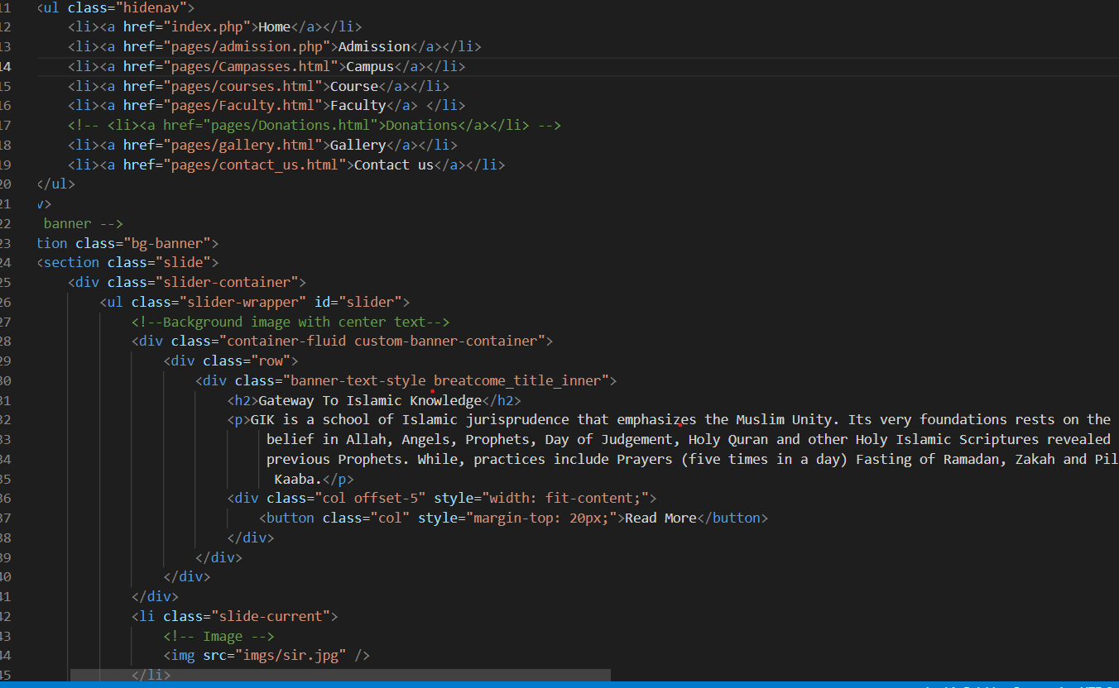

Figure 26:User Interface view Code

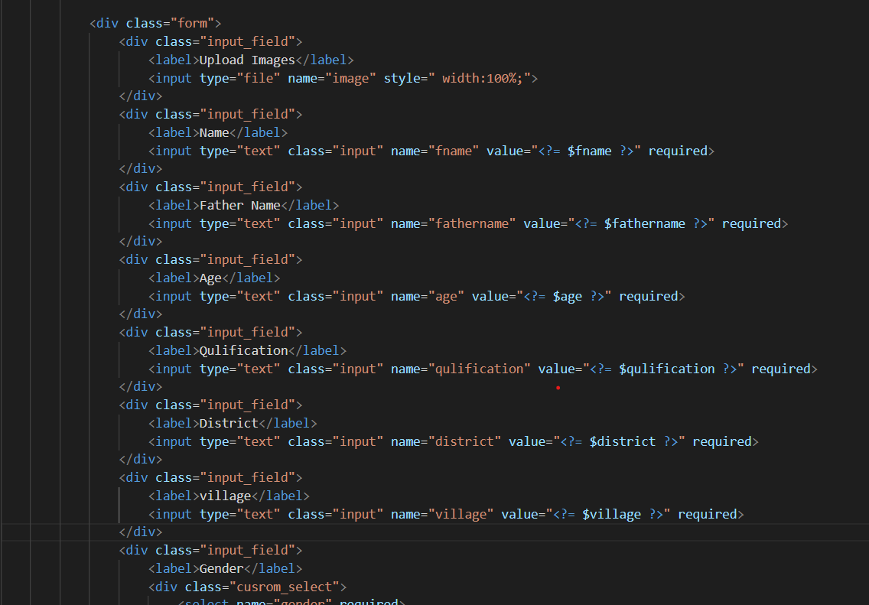

Figure 27:Admission Form View Code

This code allows users to submit their information concluded a system. When acquiesced, the code salvages the data, inserts it into the database if there are no mistakes, and displays a success or error message consequently.

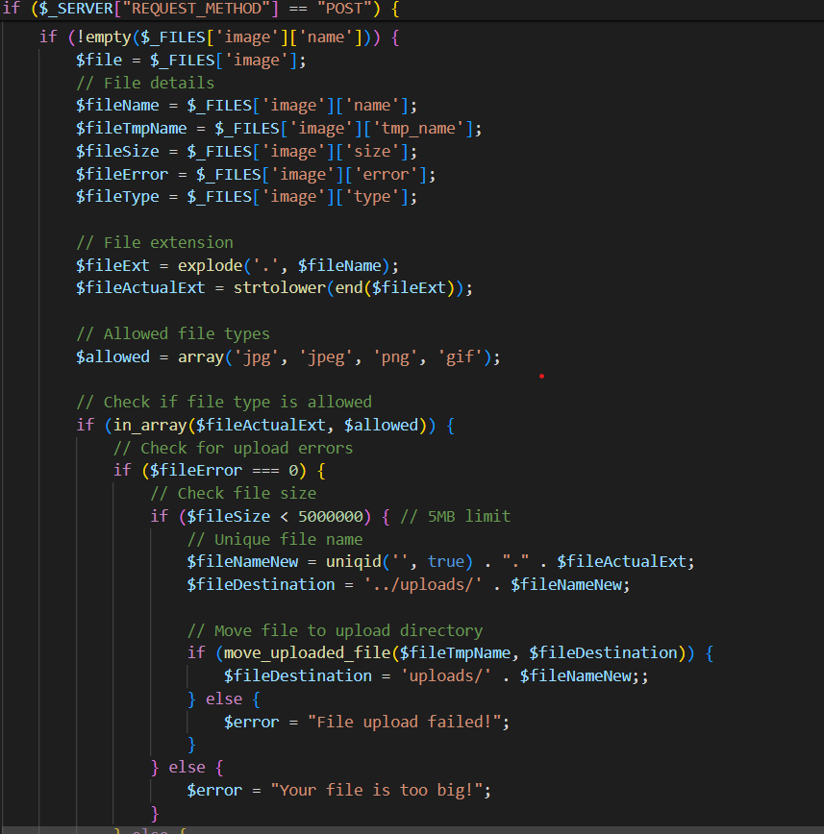

Figure 28:Image Validation Code

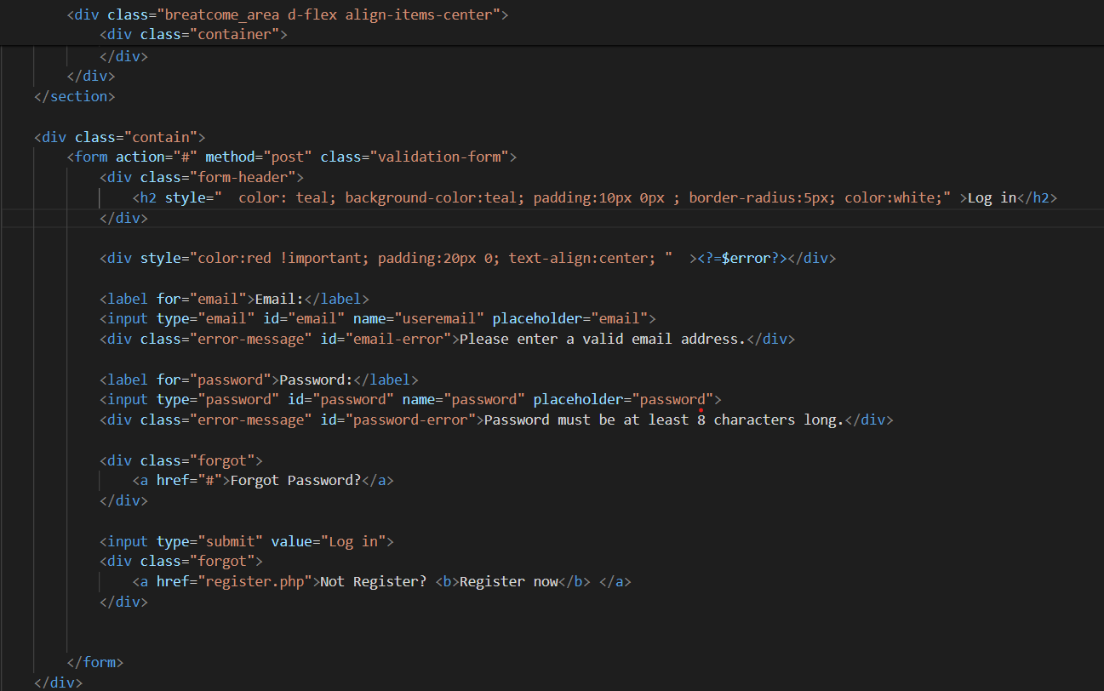

Figure 29:Login Form Validation View Code

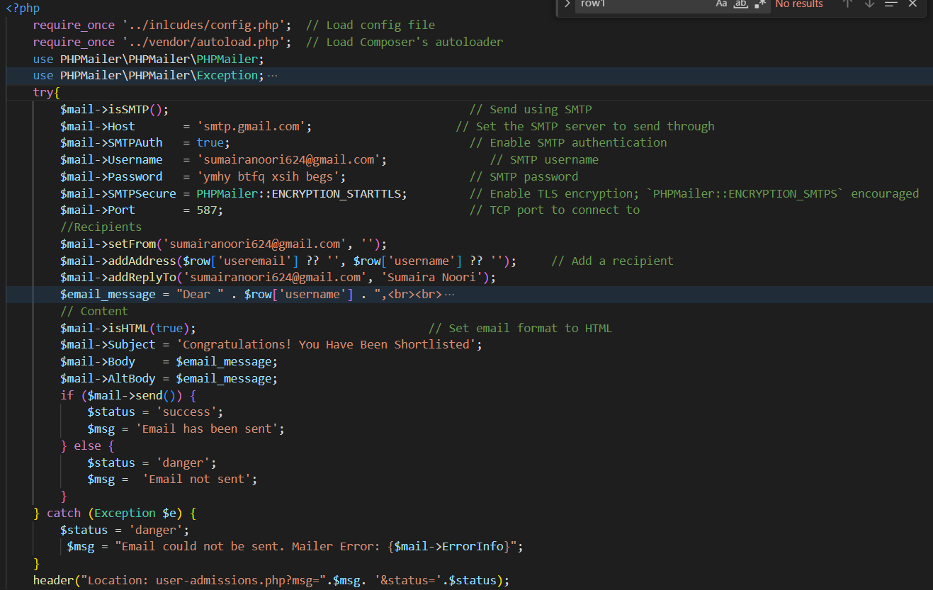

Figure 30:Email Conformation Code

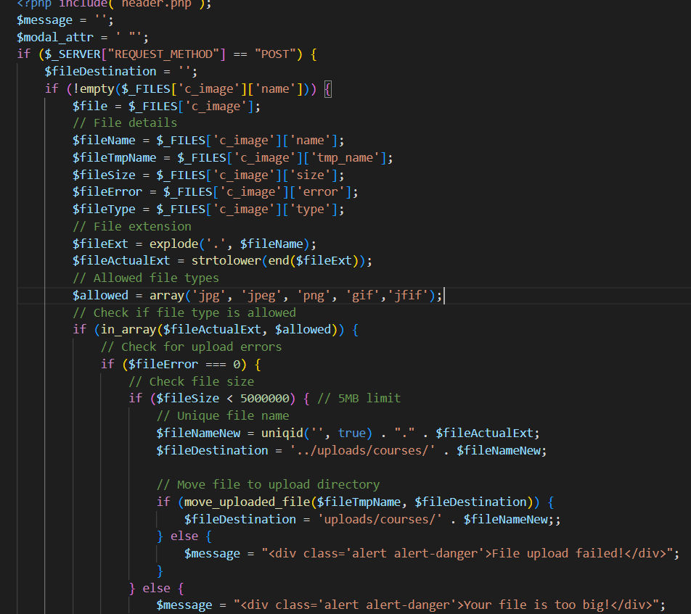

Figure 31:Course Update view code

This PHP code directs an email notification to a shortlisted candidate for admission to an Islamic school. It retrieves the candidate's information from a database table named admissions and builds a sycophantic email letter.

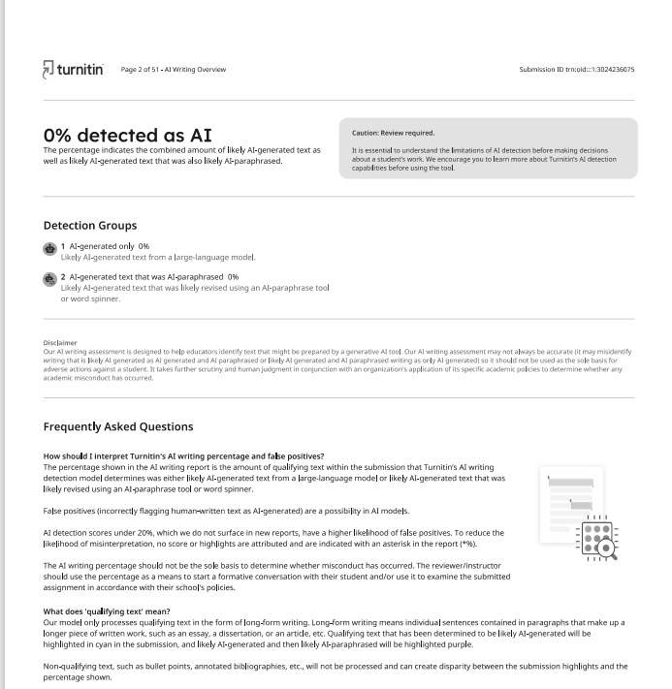

Figure 32:AI Report

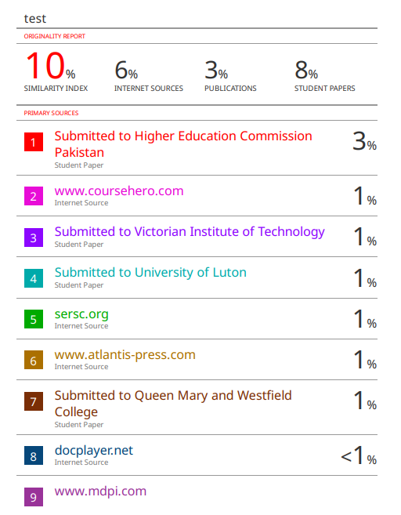

Figure 33:Plagiarism Report

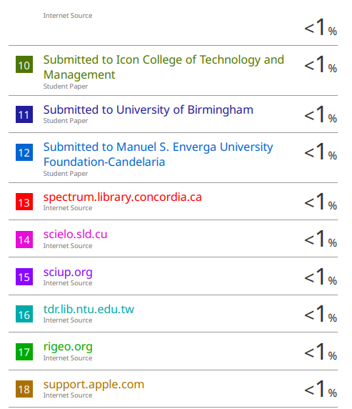

Figure 34:Plagiarism Report